Contents
Project Title 1
1. Objective 1
2. Business Requirement 2
3. Solution Overview 2
4. AWS Environment Details 3
5. EKS Cluster Creation 3
6. Worker Node Details 7
7. Kubernetes Namespace Creation 8
8. Initial NGINX Restart Validation 8
9. Liveness Demo Application 8
10. ConfigMap Implementation 9
11. Deployment Implementation 10
12. Liveness Probe Configuration 11
13. Failure Simulation 11
14. Automatic Restart Validation 11
15. Failure Evidence 12
16. Results Achieved 13
17. Benefits 13
18. Conclusion 14

Project Title
End-to-End Kubernetes Pod Restart Automation using Amazon EKS Liveness Probe, Health Monitoring and Self-Healing Mechanism

1. Objective
The objective of this POC is to implement an automated Kubernetes pod recovery mechanism using Amazon EKS.
The solution provides:
- Automated unhealthy container detection.
- Kubernetes liveness probe-based health monitoring.
- Automatic container restart after health check failure.
- Application availability improvement.
- Reduced manual operational effort.
- Kubernetes self-healing capability.

2. Business Requirement
Modern applications require continuous availability and automatic recovery capabilities.
Common application challenges:
- Application process may become unhealthy while the container is still running.
- Manual pod restart is required during failures.
- Application downtime impacts business availability.
- Operational teams need automated recovery mechanisms.
The required solution should:
- Monitor application health continuously.
- Detect unhealthy application conditions.
- Restart failed containers automatically.
- Recover application without manual intervention.

3. Solution Overview
The PoC uses AWS and Kubernetes native services:
Component | Purpose
Amazon EKS | Managed Kubernetes platform
Existing AWS VPC | Network foundation
Managed Node Group | Kubernetes worker nodes
Namespace | Application isolation
Deployment | Application lifecycle management
ConfigMap | Application code management
Liveness Probe | Application health validation
Kubelet | Failure detection and restart
Container Runtime | Application execution
Architecture Diagram
Users

HTTP Request

| Kubernetes SVC |
|
Flask Application

| Liveness Probe |
| /health endpoint |

kubelet monitors

Health Failure Detected

Restart Container

Application Available

4. AWS Environment Details
AWS Account Validation
Before creating the EKS cluster, AWS identity was verified.
Command:
aws sts get-caller-identity
Output:
{
"UserId": "XXXXXXXXXXXi-051fa96c0948dbd14",
"Account": "466749146115",
"Arn": "arn:aws:sts::466749146115:assumed-role/Prasad-Cluster/i-051fa96c0948dbd14"
}

AWS Configuration Details
Parameter | Value
AWS Account | 466749146115
IAM Role | Prasad-Cluster
Region | ap-south-1

5. EKS Cluster Creation
5.1 Prerequisites
The following tools were configured:
Tool | Purpose
AWS CLI | AWS resource management
kubectl | Kubernetes administration
eksctl | EKS cluster provisioning
Verify AWS CLI
aws --version
Verify kubectl
kubectl version --client
Output:
Client Version:
v1.36.2
Verify eksctl
eksctl version

5.2 Existing VPC Configuration
The EKS cluster was created inside the existing VPC.
VPC Details
Parameter | Value
VPC Name | Prasad-vpc
VPC ID | vpc-0a15fa78fb8b199f6
Region | ap-south-1

Subnet Details
Subnet Name | Subnet ID | Availability Zone
prasad-pub1 | subnet-01ff324c046abd0a6 | ap-south-1b
prasadpub | subnet-00d252d42e6758655 | ap-south-1a

5.3 Create EKS Cluster Configuration File
Create the file using the following command:
vi pod-restart-demo-cluster.yaml
paste the below Configuration into pod-restart-demo-cluster. yaml :
apiVersion: eksctl.io/v1alpha5
kind: ClusterConfig
metadata:
name: pod-restart-demo
region: ap-south-1
vpc:
id: vpc-0a15fa78fb8b199f6
subnets:
public:
ap-south-1a:
id: subnet-00d252d42e6758655
ap-south-1b:
id: subnet-01ff324c046abd0a6
managedNodeGroups:
- name: pod-restart-workers
instanceType: t3.medium
desiredCapacity: 2
minSize: 2
maxSize: 3
amiFamily: AmazonLinux2023
volumeSize: 20

5.4 Create EKS Cluster
Command:
eksctl create cluster -f pod-restart-demo-cluster.yaml
The command creates:
- EKS Control Plane
- Managed Node Group
- IAM Roles
- Security Groups
- Kubernetes Networking
- CoreDNS
- kube-proxy
- AWS VPC CNI
5.5 Configure kubectl Access
Command:
aws eks update-kubeconfig \
--name pod-restart-demo \
--region ap-south-1
Output:
Added new context for cluster pod-restart-demo

5.6 Validate Cluster
Run below Command:
kubectl get nodes -o wide
Output:
NAME STATUS
ip-10-0-1-144.ap-south-1.compute.internal Ready
ip-10-0-8-248.ap-south-1.compute.internal Ready

Refer to the cluster, nodes & addon creation snippet below:
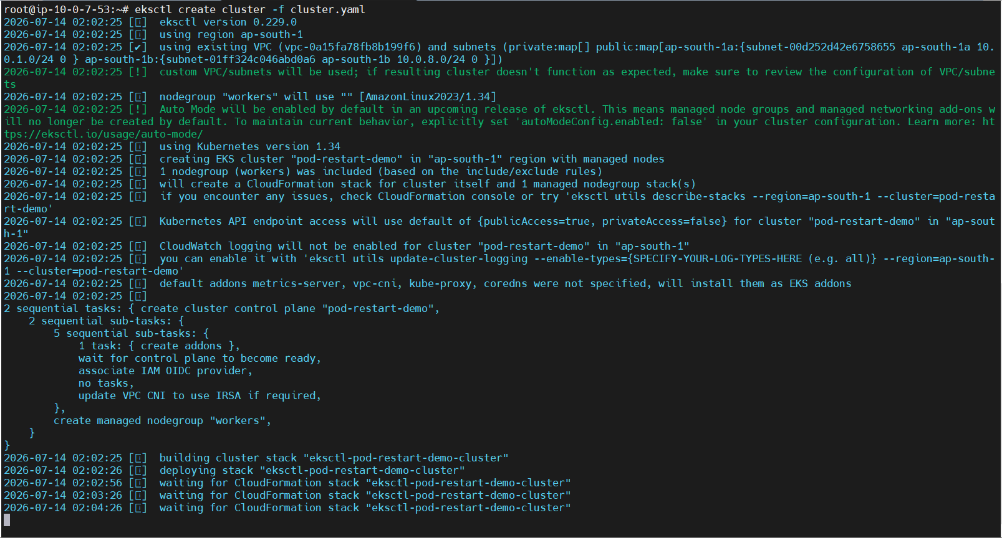

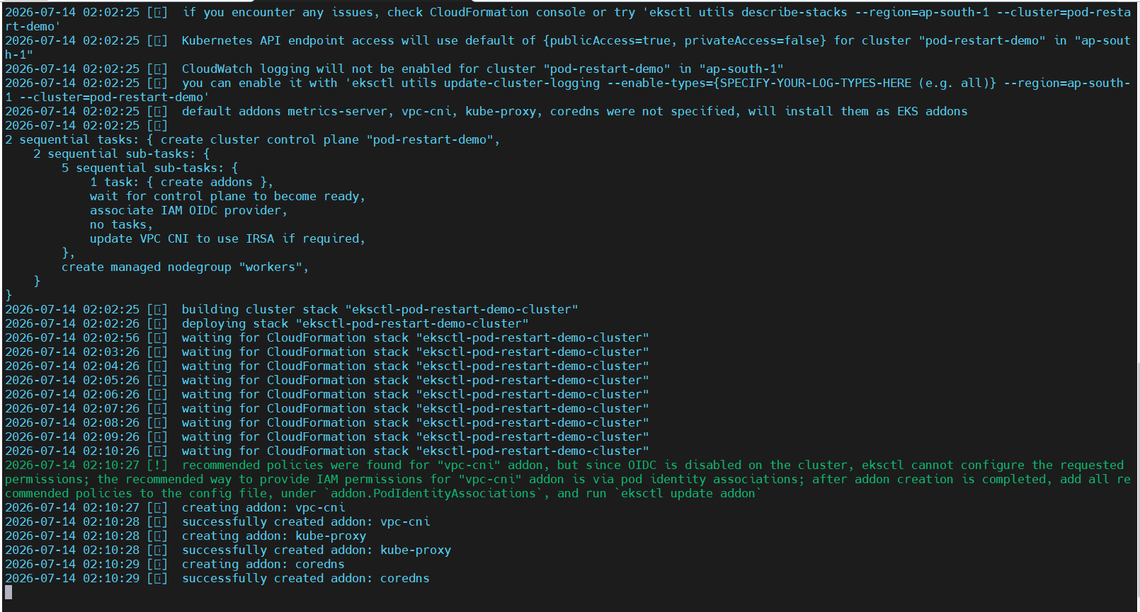

6. Worker Node Details
Node | Private IP | OS | Runtime
ip-10-0-1-144 | 10.0.1.144 | Amazon Linux 2023 | containerd 2.2.4
ip-10-0-8-248 | 10.0.8.248 | Amazon Linux 2023 | containerd 2.2.4

7. Kubernetes Namespace Creation
Create namespace:
kubectl create namespace poc
Verify:
kubectl get namespace
Output:
poc

8. Initial NGINX Restart Validation
Deployment:
nginx-demo
Purpose:
- Validate Kubernetes restart capability.
Test:
kubectl exec -it nginx-demo-pod -n poc -- /bin/sh
Run the following command inside the container:
nginx -s stop
Result:
Restart Count increased
Observation:
The container restarted, but this did not demonstrate application health failure detection.
Therefore, a dedicated liveness probe application was implemented.

9. Liveness Demo Application
Application Details
Parameter | Value
Application | Python Flask
Image | python:3.11-slim
Port | 8080
Health Endpoint | /health

10. ConfigMap Implementation
Create the ConfigMap using the YAML file below:
apiVersion: v1
kind: ConfigMap
metadata:
name: liveness-demo-code
namespace: poc

data:
app.py: |
from flask import Flask
import os

app = Flask(__name__)

@app.route("/")
def home():
return "Kubernetes Liveness Probe Demo"

@app.route("/health")
def health():
if os.path.exists("/tmp/unhealthy"):
return "Application unhealthy", 500

return "Application healthy", 200

if __name__ == "__main__":
app.run(host="0.0.0.0", port=8080)
Apply:
kubectl apply -f configmap.yaml

11. Deployment Implementation
Deployment:
apiVersion: apps/v1
kind: Deployment

metadata:
name: liveness-demo
namespace: poc

spec:

replicas: 1

selector:
matchLabels:
app: liveness-demo

template:

metadata:
labels:
app: liveness-demo

spec:

containers:

- name: application

image: python:3.11-slim

command:
- /bin/sh
- -c

args:
- |
pip install flask &&
python /app/app.py

ports:

- containerPort: 8080

volumeMounts:

- name: application-code
mountPath: /app

# Liveness Probe
livenessProbe:

httpGet:

path: /health

port: 8080

initialDelaySeconds: 20

periodSeconds: 5

timeoutSeconds: 2

failureThreshold: 3

volumes:

- name: application-code

configMap:

name: liveness-demo-code
Deploy:
kubectl apply -f liveness-demo.yaml

12. Liveness Probe Configuration
Parameter | Value
Probe Type | HTTP
Endpoint | /health
Port | 8080
Initial Delay | 20 seconds
Interval | 5 seconds
Timeout | 2 seconds
Failure Threshold | 3

13. Failure Simulation
Enter inside of pod:
kubectl exec -it liveness-demo-pod -n poc -- /bin/bash
Create unhealthy condition:
touch /tmp/unhealthy
Health endpoint now returns:
HTTP 500

14. Automatic Restart Validation
Command:
kubectl get pods -n poc -w
Result:
NAME READY STATUS RESTARTS
liveness-demo-7556d76f7f-dm5rh 1/1 Running 1

15. Failure Evidence
Command:
kubectl describe pod liveness-demo-7556d76f7f-dm5rh -n poc
Output:
Warning Unhealthy
Liveness probe failed:
HTTP probe failed with statuscode: 500
Normal Killing
Container application failed liveness probe,
will be restarted
Normal Started
Started container application
Refer to the liveness probe failure snippet below:
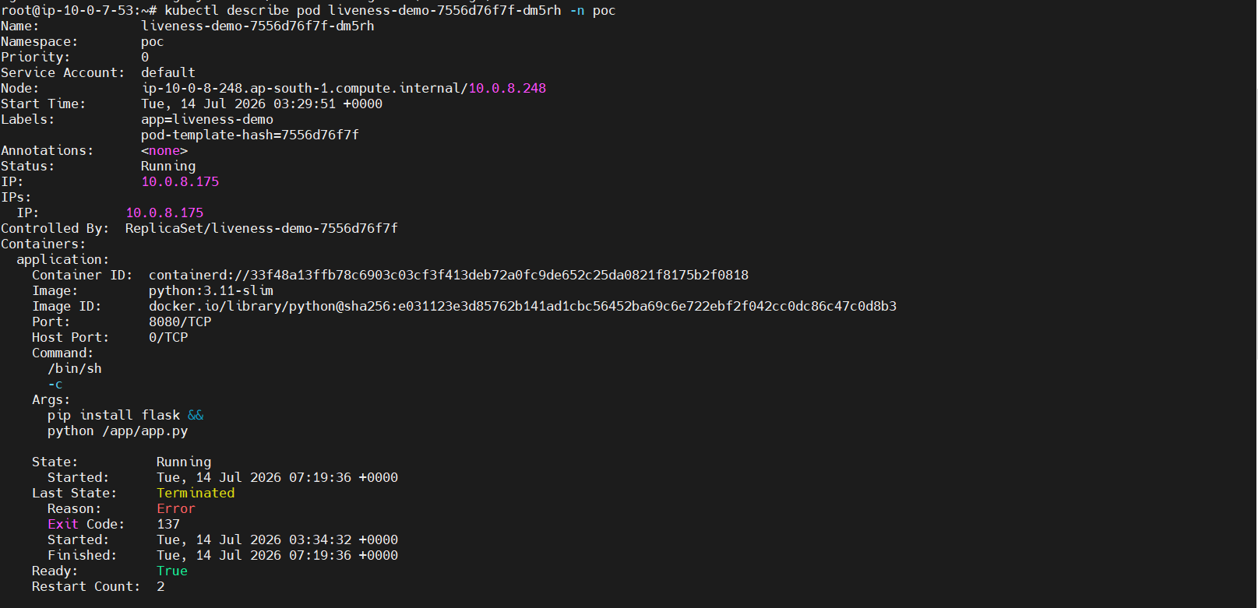
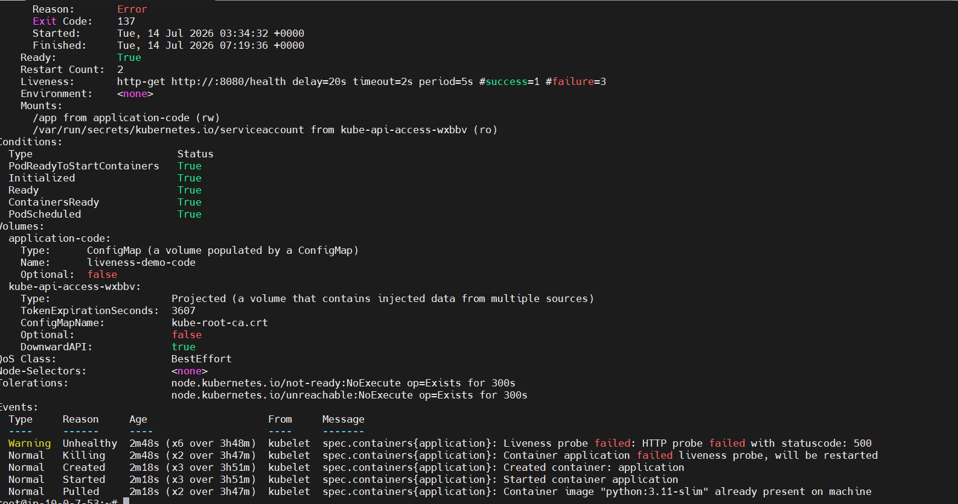

16. Results Achieved
✔ EKS cluster created successfully using existing VPC.
✔ Application deployed successfully.
✔ Liveness probe configured.
✔ Application failure detected automatically.
✔ Kubernetes restarted unhealthy container.
✔ No manual restart required.
✔ Application availability improved.

17. Benefits
✔ Automated pod recovery
✔ Kubernetes self-healing capability
✔ Reduced downtime
✔ Improved application stability
✔ Production-ready health monitoring approach
✔ Supports DevOps automation practices

18. Conclusion
This POC demonstrates an end-to-end Kubernetes self-healing implementation using Amazon EKS and Kubernetes Liveness Probes.
The solution successfully validates:
- EKS infrastructure provisioning
- Application deployment
- Health monitoring
- Failure detection
- Automatic container restart
- Application recovery
The implemented architecture provides a scalable foundation for highly available Kubernetes applications.
***************************

